Computer Language Coding Concepts

Inactive Clauses in a Command Call in a Diagram
Inactive clauses in a command call have been conceptually explained in the article Inactive Clauses in a Command Call.

This article only illustrates how inactive clauses in a command call look in a diagram.

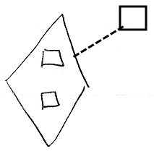

The diamond shape is a command call. The command definition of the command call is pointed out by the dashed line, pointing at the square on the right, which is the command definition. The diamond contains two squares, that do not redirect. Those are the inactive clauses inside the command call. They are clauses, because they are situated inside a command symbol and they do not redirect their target.

The creation behavior of inactive clauses in a command call will not be further explained with diagrams in this article. Refer to the article Creation Behavior of Command Callls in a Diagram for an illustration of how the creation behavior of command calls looks in a diagram.

See also: Inactive Clauses in a Command Call,
Creation Behavior of Command Calls in a Diagram

Author & Copyright: Jan-Joost van Zon Date: August 9, 2008 – August 9, 2008 Location: Oosterhout, The Netherlands Status: Under Construction | Finished

